Santa Ana College (SAC)

Mascot Survey 2022

Survey of students’ opinions of SAC’s current mascot, The Don





Prepared by KK & MD, 08/2022.

**Introduction**

During a SAC Student Success and Equity Committee Meeting in the late Fall 2021 semester, the Associated Student Government (ASG) and Mascot Taskforce members, led by Maria Aguilar Beltran and Alicia Kruizenga, indicated that there were some concerns that SAC’s mascot, “Don,” may have negative meanings or connotations related to oppressive Spanish land owners. They also indicated that some individuals voiced that the meaning is not necessarily negative. Upon further discussions in follow-up meetings in the Spring 2022 semester, the Mascot Taskforce recommended that a survey be sent out to all students to get their feedback on the mascot and help determine whether or not it should be changed.

*Survey Instrument* (created in SurveyMonkey)

* Total of 10 questions, including basic demographics.
* Survey respondents were asked about whether or not they knew what the SAC mascot is. Following the question, respondents were provided with the answer and reasons for changing or keeping the mascot were displayed side by side, one pair at a time (see Appendix A).
* After the last pair of reasons for changing or keeping the mascot was shown, respondents were asked about their level of satisfaction with the mascot, feeling of connection to the mascot, whether or not the mascot should be changed, and suggestions for a new mascot if a change was recommended.

*Survey Administration*

* The survey web link and QR code was distributed via email and text messaging by Young Kim and Dalilah Davaloz from the SAC Public Information Office. Young Kim also posted flyers with links to the survey created by John Nguyen from the Student Life Office to electronic monitors throughout campus as well as social media.
* Survey open online from 05/18/2022 through 06/30/2022.
* A total of 936 students responded. In order to lower the likelihood of multiple survey response submissions by the same student, a question asking students about prior participation was included at the beginning of the survey. Respondents who indicated prior participation were directed to the end of the survey.
* Of the 936 who responded, 44 (4.7%) indicated prior participation. Thus, the final sample size was 892.

**Demographics of Survey Respondents**

**Student Type**

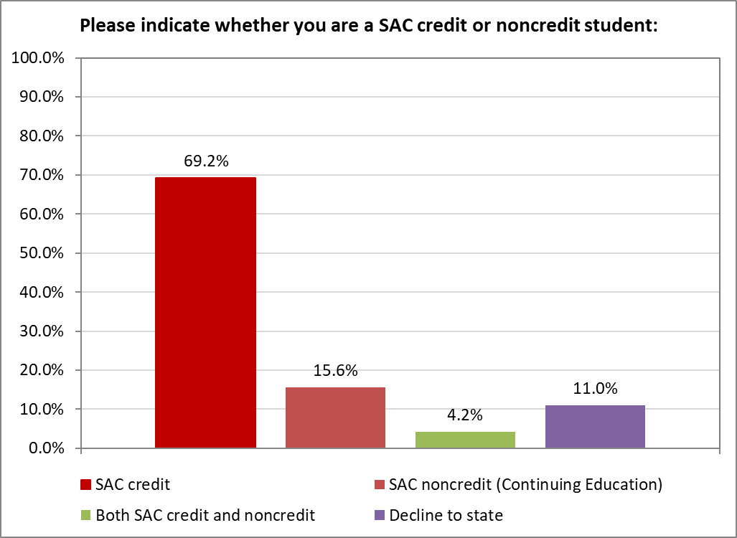

A majority of the respondents were SAC credit students (69.2%).

**Gender**

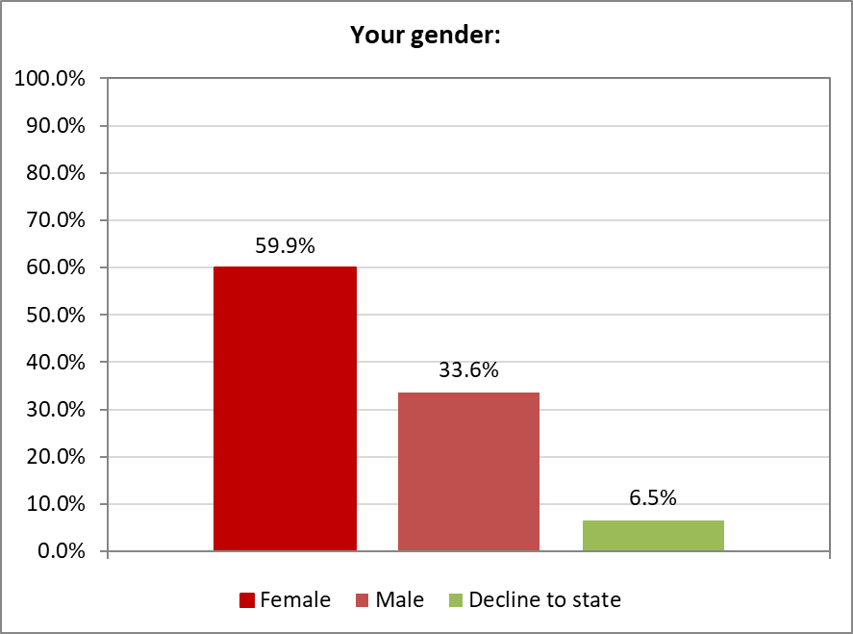

The percentage of female survey respondents was almost double the percentage of male survey respondents.

**Age Group**



The 3 largest survey respondent age groups were 20 to 25 (30.5%), 30 to 39 (16.5%), and 19 and under (15.5%).

**Racial Group/Ethnicity**

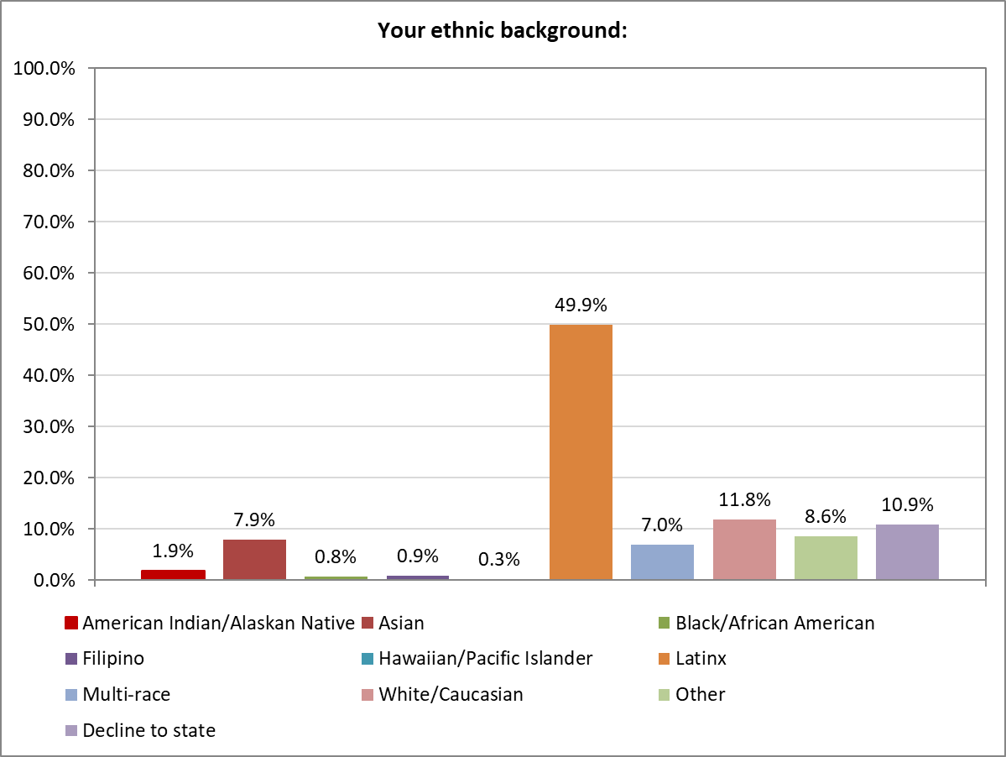

Approximately half of the survey respondents identified as Latinx, while 11.8% of respondents identified as White/Caucasian and 7.9% identified as Asian.

**Survey Results**

Prior to asking students to provide feedback on SAC’s mascot, students were asked if they knew what the mascot is. About half of the respondents *did not know* what the mascot is (448 out of 868, or **51.6%**). All students, regardless of their answer, were then shown reasons for changing or keeping the mascot, one pair at a time, to allow an opportunity to learn more about the mascot before providing feedback. The results of the questions asking for feedback are described below.

**Student Satisfaction with The Mascot**

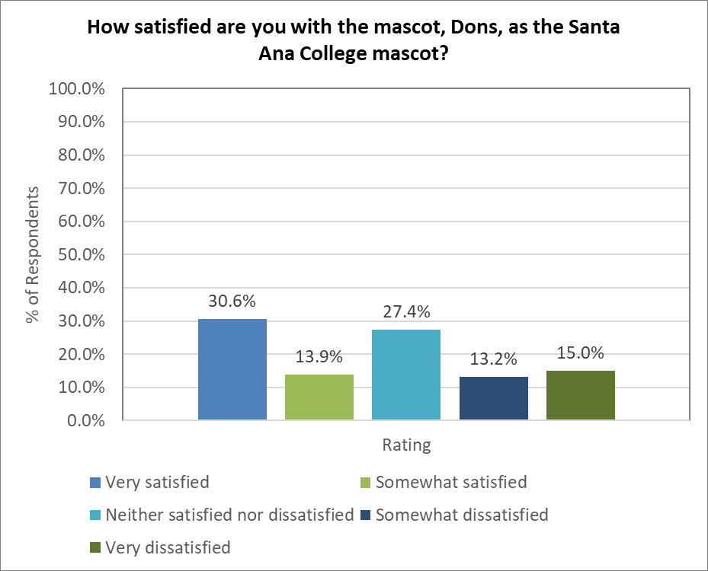

Almost 45% of respondents indicated being either “Very satisfied” or “Somewhat satisfied with the “Neither satisfied nor dissatisfied” with the mascot. About the same number of respondents were “Very dissatisfied/Somewhat dissatisfied” or “Neither satisfied nor dissatisfied” with the mascot.

**Student Connection with The Mascot**

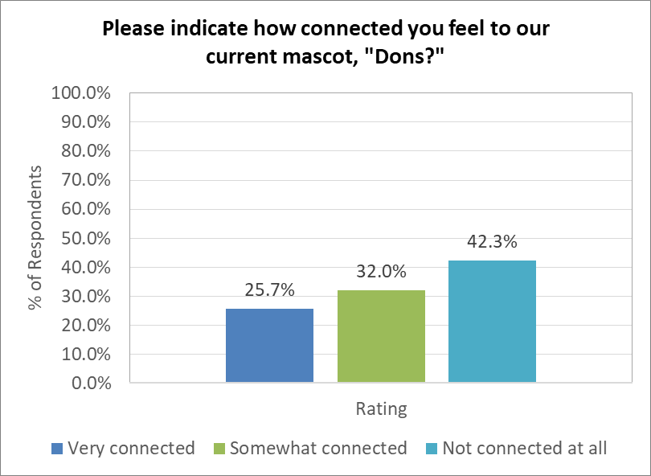

A majority of respondents (57.7%) indicated feeling “Very connected” or “Somewhat connected” to SAC’s mascot compared to 42.3% who felt “Not connected at all.”

**Reasons for Changing or Keeping SAC’s Mascot and Suggestions for a New Mascot**

* When asked whether or not they would like to see a change in the school mascot, approximately 58% responded that they would *not* like to see a change.
* Respondents were then asked to provide reasons for their answers in a comment box. The open-ended comments were grouped according to themes that were identified and are provided below.
* For comments that were in another language, Google Translate was used for categorization only. All comments shown are verbatim, including comments in a language other than English.

**Survey Question: Would you like to see a change in the school mascot?**

If the answer was **Yes**, then students were asked to indicate their reason(s) for why the mascot should be changed. There were 6 themes identified.

**First Theme: *Outdated/Needs Update***

Sum = 43

Comments:

* Pick something unique to our history or future.
* I believe the Don does not promote school spirit, nor is it universally identifiable to students. Because it is specifically related to males and to Hispanic heritage, it does not serve as an ambassador for the school. Lastly, the logo depicts something evil or criminal to me, and is outdated.
* I think a change would be good and exciting for the students
* It's old and outdated and does not reflect inclusiveness or gender neutrality.
* I think the mascot should be changed into something new and cool.
* Just to give a fresh look
* Overall history as described from previous moments ago, I think it’s time to change it.
* New change with all the remodeling done.
* It would be a nice change. The school itself is being changed, remodeled, upgraded. Maybe a new mascot could fit the new school better.
* Seems outdates...male, macho, related to one ethnic background
* Need more identity and modern change
* Excludes different cultural backgrounds and is male specific
* I went over it and It didn't motivate me. It didn't drive me or move me in any way. Times have change. We need to be proud and draw a flag that we all know. The whole city should know it when they see it. I never hear of this Don...I don't know what it looks like.
* It’s outdated. It’s not inspiring or motivating.
* I think a change would be good, I feel that's why this survey was done because there are people who are no longer comfortable and want a change
* Something different
* I didn’t know the mascot and I think it is outdated. I also still don’t understand why a don is a good mascot, even after the explanations.
* It should be changed because we need something better to represent our school and our students.
* Change keeps us current. Lol.
* Is outdated
* the historical contexts regarding Don and the indigenous peoples, although the meaning has now changed to a sign of respect like sir, the historical connotations are still present which should not be taken lightly when choosing a mascot.
* I think it's not very relatable or necessarily inspiring and I feel like there is an opportunity to create a new, more up to date, and more memorable mascot that could be decided by a larger group of people than 10's of people in the 1920s.
* After taking a Mexican American history class at SAC, I learned about what a Don was. From the things I have learned the Dons were not great people, they committed injustices against other people, especially the indigenous peoples. Keeping the Don as our mascot in the day we are in now seems ignorant. We need to accept that things have changed, and changing the mascot could show that. We should not have a mascot that could be found offensive to certain groups of people. The history in being the Dons at SAC should not overpower the hurt it could be causing people. Things change, names change, mascots change, and I think SAC, who is suppose to be accepting and embracing of diversity, should accept that and make the change.
* I think Santa Ana College is place that includes Everyone! I felt like I belonged and will be part of this school until the day I die! If the mascot needs to be changed for the purpose of students feeling more at home I am here for the change! but if doesn’t change I am okay with too!!! Santa Ana college is the best school ever!! Thank you for everything you do for us!
* Times change, we are more diverse and blended as a community now than ever
* It seems both male dominant and somewhat “overlordish”. I would prefer a name that potentially uplifts both the Hispanic heritage of Santa Ana and the indigenous peoples who were here previously.
* I think it's a great historical name, but given the recent campus upgrades and buildings, it's time for another mascot. I suggest Monarchs since it's like a rebirth of SAC, Monarchs was also a previous suggestion, and it's a Mascot to many little leagues in Santa Ana City, including Mater Dei.
* It’s outdated and it represents colonialism.
* I feel Don has an ancient vibe. The school is modernized so the mascot doesn’t fit the school image. Personally, I can hardly relate to Don.
* Yes: No physical mascot, Not widely known, “out-dated”
* Mascot represent for present & future of the school. History is important but it should be in museum. Change msacot means refresh the image/ the face of school, not change core value; and it shows the school is adaptive and develops.
* I think it is outdated and is too specific in terms of culture and gender as well. It doesn’t feel like something I can relate to.
* I think it should be changed for the reason given previously. Change is good
* Time for a change
* outdated and doesn't hold the same meaning anymore
* In the beginning, I had no idea what a Don was. It took me almost a year to recall what our mascot even was. I think we should change the mascot to something more known, but still keeps the historical aspect of it.
* it's good to renew
* A hundred years demands a refresh or reexamination of sorts; that, along with the somewhat negative connotation of Don, demands that the mascot be looked at.
* I think it should change into some short of spirited animal just because it rolls of the younger better
* I think it’s time for something new and not many people know what a don is or means
* Just something new
* It should be changed because the times are changing, and honoring tradition isn’t a good enough reason to excuse problematic practices.
* Don mascot is not something you see often, but not a lot of people know what it is. I think a change would be nice.

**Second Theme: *Don’t know what Don is***

Sum = 40

Comments:

* I still have no idea what a Don is.
* I am not an ENG, writer. ESL- Student. Primer LENGUAJE - Espanol- La educacion, es un derecho UNIVERSAL. El lugar, donde se recibe. Puede ser cuaquier lugar. Me siento incomodo por la coneccion grafica. REALEZA ( mision) y la clase (Don). Resabisos de una conquista-invasion. Una NARANJA. UN LIBRO. UNA ESTRELLA. EL ESTADO. (SAC- estilizado) Me sentiria mas, satisfecho, del EMBLEMA. Si llega, un concurso, para la propuesta de cambio. Ya tengo, mis propias ideas. Gracias, por tener las PUERTAS ABIERTAS y hacer esta encuesta. El saber, es poder, y el unico bien inapropiable.
* No one knows what our mascot is. And it is exclusionary to non-Hispanic students. Therefore we should change our mascot.
* I don’t resonate with the mascot and I still don’t fully understand what it is. Considering all the upgrades and changes that have been going on at campus, I think that it’s fitting that the mascot also changes.
* As a student, I had no idea what our mascot was until a year in and even after I was told of the mascot, I had no idea what it was until I searched it up.
* Dont really know much about the Dons..
* Some people don’t even know what a don is or looks like
* I didn’t even know what our mascot was, but now that I do, I don’t like it
* I feel people dont know what the mascot is, ive been there for three years and always forget what the mascot is.
* I went over it and It didn't motivate me. It didn't drive me or move me in any way. Times have change. We need to be proud and draw a flag that we all know. The whole city should know it when they see it. I never hear of this Don...I don't know what it looks like.
* I didn't know the school mascot was a Don until now
* I think it should be changed because not everyone knows what our mascot is and it could be confusing!!
* I did not have idea that the mascot was a Don.
* I had no idea what the mascot was, until I searched it up and even then I was like what is it??? I am Hispanic, and I still didn’t know…
* No everyone knows what a don is.
* I didn’t know the mascot and I think it is outdated. I also still don’t understand why a don is a good mascot, even after the explanations.
* No one knows about the Don.
* Not a lot of people know what a don is
* Most people dont know what it is
* I don’t really have an image of a don would look like
* Because I don't know what Don is even supposed to be.
* The current mascot is not easily recognizable
* I did not previously know the school’s mascot. But “Don” is not very relatable at all and very masculine as well. I believe it should be more gender-neutral.
* something that all recognize and know what it is
* Most of the students at SAC don’t know about the mascot since it was implemented so long ago
* I'm not sure, because I just discovered what the mascot was. There's little representation like little events and representation of clubs or groups. I've heard of the dons store but didn't know that was after the mascot. I am now learning who/what the mascot is and it's history.
* “Dons” it doesn’t sound right. To be honest I had no idea “Don” was our mascot, I thought it just the name of a sponsor.
* In the beginning, I had no idea what a Don was. It took me almost a year to recall what our mascot even was. I think we should change the mascot to something more known, but still keeps the historical aspect of it.
* I've graduated and come back and while attending the first time had no history of the mascot. Any apparel purchased would not have the mascot due to the lack of connection to the school mascot. My sister who currently attends also has no history of our school mascot.
* It should be changed because I didn’t even know what the Don was and it’s historical connection could be questionable at times.
* I think it’s time for something new and not many people know what a don is or means
* Yes, i think it should be changed because i didn’t even know we had a mascot until i saw the post on instagram.
* I’m still not even sure what a Don is. It should be something more specific
* I feel with it is very vague. The Dons is not an animal or person you can visualize
* I have been attending sports event for several years now and people keep on asking me what are the Dons!
* Not many people know out mascot and most of us don’t like it
* No one knows what is a don
* Don mascot is not something you see often, but not a lot of people know what it is. I think a change would be nice.
* most people don’t know the mascot is Dons or even what it means
* It's not well known. When I think of SAC I don't think Dons.

**Third Theme: *Not Diverse Enough***

Sum = 40

Comments:

* A new mascot that can honor the don yet, represent everyone in todays diversified society
* The name DONS is not representative of the Santa Ana Community and normalizes male gender pronouns. The name speaks to colonial violence of settlers who settled in unceded indigenous lands.
* A mascot should generally connect as much of the student body as possible. It doesn't feel like the Don does that. Also, the physical and architectural landscape of the school has changed over the years and we should have a mascot that reflects that evolution.
* No one knows what our mascot is. And it is exclusionary to non-Hispanic students. Therefore we should change our mascot.
* I think that this "Don" figure represents only a portion of the Hispanic culture: the South Americans. SAC's mascot seems a lot more like a "Gaucho" which is a cowboy of the South American Pampas. "The figure of the gaucho is a folk symbol of Argentina, Uruguay, Rio Grande do Sul in Brazil, and the south of Chilean Patagonia." (Wikipedia). I am guessing that most of the Hispanic population at SAC, may have more like Mexican ancestry than South American, so in a way, it does not even represent the largest ethnic SAC'S population.
* It depends on the culture of the school the representation.
* I want something that sounds inclusive, represents everyone.
* The racist history and legacy of the dons is problematic and offensive to Indigenous Nations who still live on these lands.
* Too specific to historIcal terms that may offend and does not reflect powerful team play
* A mascot figure should represent santa ana college vition... opportunity, teaching, progress"for everyone as Santa Ana college has always provided!
* I would like to have a mascot’s that has a diversity culture
* I think it’s not inclusive and can be seen as negative due to its history with Native Americans.
* As it was mentioned before, now the college it is multicultural, plus there is diversity in nationalities.
* The mascot, Don, is not easily identifiable as a person who is not a part of the Latin culture. I am ok with having a name linked to Latino heritage if it is something that we all would understand.
* Prior to being a student at sac I had no idea that sac even had a mascot. We should strive to find a mascot which appeals to everyone santanero not just Hispanic santaneros. We should be recognized before students attend our college. For example everyone knows USC mascot is the Trojan.
* More relatable to all students. SAC already feels like it caters to the Hispanic community so at least the mascot should be neutral
* Don refers to man and I know it also referred to a gift but I feel like we need something that includes everyone because I feel like not every one realizes what Don means.
* Excludes different cultural backgrounds and is male specific
* More representative of the multicultural community at Santa Ana College. To me, the don represents oppression of Indigenous voices.
* I’m torn but I think that having a Spanish Bible as a mascot is not ethnically inclusive of the school population. Historically I also don’t feel that it’s positive for the ingenious Americans.
* Because we need change and diversity within our community. And to better strive to become a more progressive society
* It does not represent me, it does not represent people of color nor people who identify as anything other than man
* After taking a Mexican American history class at SAC, I learned about what a Don was. From the things I have learned the Dons were not great people, they committed injustices against other people, especially the indigenous peoples. Keeping the Don as our mascot in the day we are in now seems ignorant. We need to accept that things have changed, and changing the mascot could show that. We should not have a mascot that could be found offensive to certain groups of people. The history in being the Dons at SAC should not overpower the hurt it could be causing people. Things change, names change, mascots change, and I think SAC, who is suppose to be accepting and embracing of diversity, should accept that and make the change.
* Honestly, where I am from a Don is a landowner who does not treat the natives or any minority very well. Since there is a large minority population at the school, the name should reflect that.
* The “Don” stands for everything against inclusion and diversity. I understand we have a large Hispanic/Latino community, but we should also be open to other cultures and communities. Also, being that it is gender specific; where’s the inclusion there?
* Times change, we are more diverse and blended as a community now than ever
* It seems both male dominant and somewhat “overlordish”. I would prefer a name that potentially uplifts both the Hispanic heritage of Santa Ana and the indigenous peoples who were here previously.
* Dons are representative of a culture destroyed by European invasion, and exemplifies the appropriation of white culture over true natives.
* The mascot, in my opinion, should be all inclusive (genders, cultures, traditions), and should be forward looking (not trapped in historical references that are too far removed from today's students). It should make students feel pride and confidence and not have any negative connotations. While I believe the demographic of SAC students is primarily Hispanic, perhaps a more "generic" mascot can be found that is just as welcoming.
* Don is for Hispanic people and students from other nationalities have to idea idea about it and might not feel identity with the current mascot
* I think it is outdated and is too specific in terms of culture and gender as well. It doesn’t feel like something I can relate to.
* It' meaning is confusing and doesn't represents our multicultural population at SAC.
* Based on everything that was indicated the mascot needs to be gender non-specific and racial nonspecific it needs to Bringing no matter what gender no matter what culture
* It is not inclusive of all students
* I think the current mascot is only representative of one origin/ethnicity/heritage and that is the Mexican/Hispanic culture. For a school that is already known to specifically cater more to Mexican/Americans/Chicanos, I feel It is only fair to change the mascot.
* I believe we should change out mascot because it should be more gender inclusive and heritage inclusive
* Should be a mask majority of the students can relate to or connect with
* Not inclusive
* I think the term “dons” isn’t including about people of other ethnicities
* I don’t feel connected with our mascot because there is a lot of historical and cultural exclusion behind the Don. Although it’s been very established over time, change is necessary sometimes.

**Fourth Theme: *Not Gender Inclusive***

Sum = 17

Comments:

* To me, the Don is gendered and represents something from a part of California history that we shouldn't be lauding.
* I believe the Don does not promote school spirit, nor is it universally identifiable to students. Because it is specifically related to males and to Hispanic heritage, it does not serve as an ambassador for the school. Lastly, the logo depicts something evil or criminal to me, and is outdated.
* It's old and outdated and does not reflect inclusiveness or gender neutrality.
* In my country I grow up calling older men with that title and it was considered disrespectful if I forgot to use it, that's why I don't like that name.
* The current mascot, the Don, should change because the newer student generation barely recognizes this mascot. Moreover, the Don embodies a machismo ethos that can alienate non-gender-conforming students to identify with their school's mascot. Although the old mascot has a long-standing history, future-forward thinking students will not be convinced by appeals to tradition as a reason to keep the Don. It is time to embrace a new mascot as a positive change for the school to show students, other colleges, and the local community that SAC always seeks to represent the modern ideals of its current students.
* Don refers to man and I know it also referred to a gift but I feel like we need something that includes everyone because I feel like not every one realizes what Don means.
* Mostly because it excludes all other genders but male. Mascots should not have a gender if they are to represent a whole college.
* It is not inclusive
* It does not represent me, it does not represent people of color nor people who identify as anything other than man
* The “Don” stands for everything against inclusion and diversity. I understand we have a large Hispanic/Latino community, but we should also be open to other cultures and communities. Also, being that it is gender specific; where’s the inclusion there?
* I did not previously know the school’s mascot. But “Don” is not very relatable at all and very masculine as well. I believe it should be more gender-neutral.
* The mascot, in my opinion, should be all inclusive (genders, cultures, traditions), and should be forward looking (not trapped in historical references that are too far removed from today's students). It should make students feel pride and confidence and not have any negative connotations. While I believe the demographic of SAC students is primarily Hispanic, perhaps a more "generic" mascot can be found that is just as welcoming.
* Don, as a title, was generally reserved for those who were elites of the Spanish crown. In more contemporary times in Mexico and in a lot of the USA, the title is used as a title of respect for elders no matter their socioeconomic status. However, it is very gendered and only applicable to male appearing bodies with Doña as the feminine form. Honestly, I think using human titles is a poor choice of a mascot. An animal or a non-human would be a better mascot than any human centered mascot (e.g. Vikings, "Indians", "Red Skins", Don) or at least it should be a fictional human centered mascot (e.g. Giants, Red Sox, Yankees, Angels)
* I think it is outdated and is too specific in terms of culture and gender as well. It doesn’t feel like something I can relate to.
* Based on everything that was indicated the mascot needs to be gender non-specific and racial nonspecific it needs to Bringing no matter what gender no matter what culture
* It is not inclusive of all students
* I believe we should change out mascot because it should be more gender inclusive and heritage inclusive

**Fifth Theme: *Not Appropriate/Oppressive/Offensive***

Sum = 15

Comments:

* I think it’s important to take indigenous people’s many years of struggle because of the Dons’ position many years ago.
* What I’m getting at is the “Don” was a landlord for Santa Ana in his time and what I know about landlords In This day in age is they’re not always the best examples of “great” people. Also selling off the land of indigenous people who are then caught in an endless debt loop how terrible. I hope Santa Ana doesent put its students through that with student loans then it would make more sense as to why SAC mascot is “ The Don”
* The historical background of the mascot can be offensive and hurtful towards others.
* The historical data on subjugation
* in top of the reasons given here to change the name of dons, the logo used (something that seems a person [man] wearing a hat) it reminds of a "Cholo" someone to belongs to a gang, usually aggressive, rebellious and drug related--something that does not represents scholars--Santa College Students.
* The don is an oppressive figure and a wrong representation of the native Californian (working class) folk.
* the historical contexts regarding Don and the indigenous peoples, although the meaning has now changed to a sign of respect like sir, the historical connotations are still present which should not be taken lightly when choosing a mascot.
* The name change would not personally affect me, however, I agree with this reason: "To an Indigenous person, the Dons might read somewhat akin to the group of people who treated your ancestors like slaves. It might be worth reaching out to local Indigenous communities to see if they feel that the name is inappropriate." If it is offensive to a specific group of people and insensitive to their history, then why not change it?
* Honestly, where I am from a Don is a landowner who does not treat the natives or any minority very well. Since there is a large minority population at the school, the name should reflect that.
* Dons are representative of a culture destroyed by European invasion, and exemplifies the appropriation of white culture over true natives.
* A "Don" is a leader of an organized crime family which, in perspective with SAC's location, is wildly inappropriate for the representation of the students and the people that live in Santa Ana. Imagine that in an already underserved area, a token of pride is based on mascot whose origins can be construed as a racist and inappropriate depiction for the residents of that area.
* I think it should change into some short of spirited animal just because it rolls of the younger better
* historical background is important especially if this mascot undermines the identity of our indigenous peoples, think about how they are being impacted!!
* Due to indigenous history it would not be appropriate to keep the mascot.
* Its colonizer origins given that SAC is erected on stolen indigenous lands. I would also consider removing the mission which also has historical oppressive roots.

**Sixth Theme: *NA/Other***

Sum = 60

Comments:

* Pick something unique to our history or future.
* This mascot looks scaring. If the face expression were less aggressive, it would look better.
* It needs a better picture
* I think a change would be good and exciting for the students
* The mascot should change because I dont think it's a good mascot.
* I feel that the mascot isn’t as catchy as the other colleges but I’d say the log for the mascot is really cool, it look nice on clothing
* What I’m getting at is the “Don” was a landlord for Santa Ana in his time and what I know about landlords In This day in age is they’re not always the best examples of “great” people. Also selling off the land of indigenous people who are then caught in an endless debt loop how terrible. I hope Santa Ana doesent put its students through that with student loans then it would make more sense as to why SAC mascot is “ The Don”
* Too specific to historIcal terms that may offend and does not reflect powerful team play
* I think the mascot should be changed into something new and cool.
* First of all the image looks more like a susceptor.
* The history is important for our community
* Sometimes, change can be a positive outcome. If mascots can easily be changed, they can always be turned back to the Dons, if the new ones don't fit at all.
* I don’t really know where I stand on the mascot.I would not feel upset if the name changes or not. I believe if there is a more well known name that still has some history then it should change
* The color doesn’t seem as nice as gold and blue
* I think this is not even a mascot, it's a generic word for "sir". It's like a school in China having "Mister" as a mascot, it makes no sense. If anything let's name our school after the person who established Santa Ana, not just his title.
* Something more badass.
* Dons seems like a weird mascot as it’s just a gui named don
* the Don with the mission in the back makes the mascot seem more like a place then a being
* Yes because although Dons has been around for so long, it is not an attention grabber. You want a mascot that catches the eye of students and something they can take pride in.
* I would like a pet instead.
* Animals are better mascots.
* The mascot, if it holds so much history, then keep it. However, why not better educate and promote the mascot rather than on a brief survey.
* Doesnt make much sense
* The historical data on subjugation
* The mascot should be changed. I think the most important aspect is to have something recognizable as a mascot. A Don is not something i would think as a recognizable mascot. I think having a more traditional mascot helps with school spirit and pride.
* I agree with the statements that were provided as reasons for why Don should be changed.
* I didn’t even know why our mascot was a Don
* 1.The mascot is not too specific 2. The mascot is not interesting
* “Dons” doesn’t really make any sense out of context and doesn’t engender any kind of mental image or rallying concept for students.
* in top of the reasons given here to change the name of dons, the logo used (something that seems a person [man] wearing a hat) it reminds of a "Cholo" someone to belongs to a gang, usually aggressive, rebellious and drug related--something that does not represents scholars--Santa College Students.
* The name change would not personally affect me, however, I agree with this reason: "To an Indigenous person, the Dons might read somewhat akin to the group of people who treated your ancestors like slaves. It might be worth reaching out to local Indigenous communities to see if they feel that the name is inappropriate." If it is offensive to a specific group of people and insensitive to their history, then why not change it?
* I don't think it's a mascot in which other people can take great pride in and when around proudly say that they're a "Don"
* 😃😃
* Honestly, where I am from a Don is a landowner who does not treat the natives or any minority very well. Since there is a large minority population at the school, the name should reflect that.
* No MCHS representation
* I agree with the points made in the reasons for changing in the previous slides
* Dons are representative of a culture destroyed by European invasion, and exemplifies the appropriation of white culture over true natives.
* I think the name Don was heritage based and showed honor to a particular group. While I don't like that everything historical is being destroyed or erased, society has truly changed and finds a way to take everything as an insult.
* It’s not cool.
* I don’t agree nor disagree
* El Don is ok but it needs personality it has no character
* Originally I would’ve liked it to change due to not knowing what our mascot was, but now all I would like is to change the image of Santa Ana College.
* It's rather quite boring.
* Don, as a title, was generally reserved for those who were elites of the Spanish crown. In more contemporary times in Mexico and in a lot of the USA, the title is used as a title of respect for elders no matter their socioeconomic status. However, it is very gendered and only applicable to male appearing bodies with Doña as the feminine form. Honestly, I think using human titles is a poor choice of a mascot. An animal or a non-human would be a better mascot than any human centered mascot (e.g. Vikings, "Indians", "Red Skins", Don) or at least it should be a fictional human centered mascot (e.g. Giants, Red Sox, Yankees, Angels)
* I’m not indigenous or latinix, but I think The Dons is super dumb. When I think of “The Dons” I think if mob bosses. I get it if it’s like, for a football team, but *the entire school?* that just seems a bit much. The Logo looks super cool though. I think we should keep it.
* It should be changed for better. please dont nae us generically (like gators)
* A "Don" is a leader of an organized crime family which, in perspective with SAC's location, is wildly inappropriate for the representation of the students and the people that live in Santa Ana. Imagine that in an already underserved area, a token of pride is based on mascot whose origins can be construed as a racist and inappropriate depiction for the residents of that area.
* The current Don mascot is not common to most people. I think a new mascot should be an animal or Vikings .
* Red is color of a burning torch. Passion of good instructors and greater student learning 2022.
* Although I like the facts and what it could stand for as a Latino myself I feel like having a mascot where you can actually see a clear image of that mascot would be great like for example if we did end up being the Vikings everyone knows what a Viking looks like and we would have an image of that.
* A Don is not even a mascot is just a respectful way to great an elderly
* It was chosen 100 years ago.
* Because dons not kool
* No one I know is amused with Don.
* A hundred years demands a refresh or reexamination of sorts; that, along with the somewhat negative connotation of Don, demands that the mascot be looked at.
* N/A
* I just know that I don’t really think that the Dons fit SAC.
* Horrible Mascot
* It’s confusing as the Santa Ana College logo has the mission but then you also have the Don “SAC” logo. One logo would be nice.
* I don’t feel connected with our mascot because there is a lot of historical and cultural exclusion behind the Don. Although it’s been very established over time, change is necessary sometimes.

If the answer was **No**,then students were asked to Please indicate your reason(s) for whether or not you think the mascot should be changed. There were 5 themes found.

**First Theme: *Part of History/Tradition/Culture***

Sum = 107

Comments:

* I wouldn’t want a change. I would stick with what we originally started with. That is what represents SAC.
* Because a legacy remains for generations and we will all to create identity with it.
* I believe acknowledging the origin of the mascot is important to consider. Recontextualization into modern sensibilities in an effort to modernize the mascot would be another consideration.
* The Don has meaning in the Hispanic community and to see a college represented by this minority group makes it more welcoming for all minorities.
* It has been the mascot for generations and after I read the history of it I think it's great for the present generation who might see it as an inspiration to be "El Don" or "LA Doña".
* It’s part of the school history and it should stay. It’s what gives the school it’s identity.
* I don't know to much of these cultures or fights against our country USA most of the time it was only working to get to world war 1 or world war 2 it would be amazing to just keep it Old school where I can learn original
* Our mascot is very unique and it has history behind it. Maybe it just needs to be more modern and remind students more of it.
* The mascot is so close to reaching 100 years of age.
* I would not like to see change because even if we change it to a more indigenous mascot there might be a complaint like the red skins football team, if we have it into an animal students might find it offensive either way bc that animal Only identifies as male N female they need something like a shrimp that satisfies all categories. This name has been around for a while I know local high schools have the same name like Santiago cavaliers. Let it be.
* Ties in the areas of Orange County.and its origins by the Spanish. It is a unique cultural identity that not many collages can pay homage to. As a College, this should be embraced as we hope students ascend into nobility. However, the college should explain what a Don is to the body via ASG events, orientation and instill more pride. I myself didn't really understand what it was until I learned about it my last semester at the college.
* I think we need to stop making everything " gender" "culture" etc offensive.. Don has been part of my life history and will always remain this Mascot. I do not take offense and we shall not try and speak for others that are no longer around or even care! STOP THIS!! Many of us have had enough! I support for the mascot to remain!!!
* I think the name is apart of the history of the school and the Era in which it was built.
* I like the tradition.
* This has been our mascot for over a hundred years, meaning there are 100 years worth of students who connect with this mascot. So to change it, you are disconnecting them from a school that they have amazing memories with.
* It should not be changed in honor of those who came before us.
* I believe it should stay the same just because it's always been "Don". In the mascot has so much history
* why change the name? the mascot name was chosen almost 100 years ago. I don't see a good reason to change it.
* It should stay because it part of Santa Ana history.
* Should not be changed because the history behind it. The athletic programs have a lot of history being called the dons and it just adds that fear factor when going against other teams.
* The Don mascot has been our mascot for decades and should never be changed just because some cultures don't feel connected to it. Therefore it has been with the city of Santa Ana because with its Spanish community.
* I think that having a school in the heart of the Hispanic community be a Hispanic mascot is important. It is a form of polite greeting to me and my friends, we call our fathers, Don... and the fathers of others Don as well. Be it our boss or someone we greatly respect. It is significant to us in everyday life and to be seen as a Don is a great privilege despite the fact that I am female and would not be called Don, I understand that I am one. Does that make sense?
* To be honest I never knew the mascot was the Dons. After reading some history provided in the survey. I think the name suites the story of the land very well. We should never forget the history of our city and represent its history proudly.
* Keep it as it is. A show of respect to the school.
* I think it shouldn't be change if been a history
* It’s the original
* It represents a long standing cultural theme and we should not remove things such as these
* It should stay the same for historical aspects and students’ accomplishments under that mascot
* I think the historical significance of the mascot should be respected and kept.
* As a Hispanic myself, I feel connected to the Don mascot. Santa Ana College is at the heart of Santa Ana city’s Latino community. I am very happy that there is a college mascot that represents my community.
* We should keep Don's because it's a big part of SACS history and even though it's a Spanish name SAC has never excluded any other ethnicity
* It’s part of history and it represents Santa Ana
* SAC has a great legacy, and that mascot forms a big part of its legacy.
* College and University's are know for traditions. We, at Santa Ana College, are one of the oldest colleges, we must continue and RESPECT traditions. Yes, years have past, and we are living in a new era; why not embrace our traditions and modernize it with todays era. Not by changing our mascot, but by recognizing our mascot and our school for accepting everyone equally. I would understand if our school was not open to this new era (which honestly there us just too much going on... (for example, "he/she/they/it) at the end of the day we are all humans that need to show respect for one another. Our school was founded years ago, because of our founders and students who attended years ago, we are who we are today, the Dons from Santa Ana College.
* Given we have a huge Hispanic population going to sac, it's nice to have a historical and cultural beacon of pride. Make it so it does not exclude other students with stuff only relating to the Hispanic population while also acknowledging the history behind it and throwing respect to the original culture. We don't change the Caesar Chavez building just cause he wasn't an impactful historical figure for those who aren't Hispanic.
* It's part of the college's history, removing it would just reset your school's history and personality. If you want to be different, redesign the mascot to be much more appealing, but not get rid of him.
* It is part of the history of Santa Ana College.
* I feel that Dons is a unique name. This land used to be owned by Mexico, as well. I can only speak for myself. With that said, I feel that the honor should be continued.
* It should not be changed. It literally is just a formal/respectful title you would give to someone. And Santa Ana is very hispanic. Taking away something that represents the city that the school is honestly, very disheartening. The school should be proud to represent its city and community. Taking away the Hispanic name is almost like taking away the fact that we are proud of where we came from.
* Just grew up knowing the Dons
* Tradition. There's nothing wrong, political or insulting to the Spanish culture. It honors it.
* Shows history of the school and location.
* I have been a long time student and resident of Santa Ana. El Don has my up most respect of growing up. El Don is a Master of Knowledge and wisdom. The change will ruin me as knowing the history and love of the land before it became a city. Please do not change the mascot. El D.O.N the gift, leadership and respect which now these days we don not have the human race lacks.
* We should keep it to make 100 years with it!
* Then name Don has a great history at the college and it is a Spanish term for someone over the land. Santa Ana is also a Spanish name and they fit together. The term Don, shows strength and in charge and good term for an athletic team.
* keep our history. dont follow the crowd.
* While I don’t feel connected to the current mascot I feel that there is a historic significance to the current mascot.
* No, it should not change. It’s not offensive. It’s represents the history of the College.
* For my understanding the name Dons is NOT in anyway controversial or offensive. Its origin is Spanish and what I know is that Spain played a big roll in the richness it left here in the Americas, just like the British did as well. Why is there a need to tarnish our rich history in the Americas by denoting the Colonizers as bad, is because of them that we became modernized and no longer live in caves. I have Spanish, Asian, and Middle Eastern mix in my blood and proud of it, besides the pride and honor that I have for this beautiful country the USA! If back in 1920, the alumni decided to give us the Dons nickname and mascot...I don't see the need to change it!
* The mascot name is awesome it shouldnt be changed because students dont like it now, it is part of Santa Ana college history and should continue the journey of Don.
* Historically significant.
* I think the mascot is very known in Santa Ana, if we were to change it then it would be very heartbreaking
* Is something the school have for years I don’t see a good reason to change it
* I believe that the mascot should not be changed due to its historical aspect. It represents the people who chose the mascot it shows how the college shows their past and history.
* A good opportunity to learn about and from history
* It should not. I believe in tradition and having the same mascot for over 100 years means something.
* Yes, there is a huge reason as to not change a spirited entity that many of the students before and present are not only use to seeing and knowing but it has its own being not of only talent spirit love wisdom but it has been within the family for many years and it would be upsetting to have the mascot changed. I love it as an imagery student of SAC that has the vallor dignity goal and balls to accomplish and help many to feel very proud in spirit to have a good looking mascot. Because if you change it then you change the proudness of the campus. To my the only grandest hood that I will ever claim in my life and be greatful thankful in soany ways is RSC no matter what I love the place.
* It's a spanish honorific reference. I consider the girls to be Donas. Why would we change our mascot as we have always been the Dons. I ran as a Don for track and cross country. Can't believe there is a drive to change our school heritage.
* The mascot should remain to the same to embrace the legacy this college has. Social media and other factors are influencing people to break tradition because people are easily offended. Lets just embrace the tradition and name that we have. It is upsetting to see sports teams and colleges change names. Our excellence and name speaks for itself. Let’s continue our legacy in tradition, Dons.
* It is historical and when I hear “the Dons” I instantly think Santa Ana College. It’s my college and it represents it perfectly!
* The mascot has represented the school for decades, there is no need to change it. It is a symbol of the school. It should remain. I
* Colleges and organizations are losing their sense of identity and the school has an opportunity to move into the future while respecting our historic heritage
* I think that the Name should not be changed because it is made known from the beginning
* A 100 years ago no body were waiting for a change in the natural nature of the humans. The el DON is something that we can feel part of it as a team, never something that define you, is not pointing in any bad way to an specific group of people. 100 years hago was necessary this action and it have been worked for 0ne hundred years ago that means to me it is works let's continue working with the Don.
* It's fine as is and the bit of history provided about Yorba is neat about the land's past. Also changing it to something else would be strange and kind of generic, like Vikings or tigers, etc. Dons could be common too but at least it's something different that you don't really see.
* People who have graduated might feel like the school they went to with pride and represented will no longer exist. I personally have don merchandise and show it with pride. It removing a tradition from a school full of historical history.
* It’s been Don for years, there’s no real need to change something that has had meaning for all these years
* It has a lot of history for the school and it would be unfortunate to change the name to something else.
* I think the original mascot should stay because taking it away will take away the history of the school democrats want to change our history and culture but i think ut should study especially if your not changing the name of the school keep the mascot kneel it original
* I think it is good to stick with out roots
* It has a legacy built on the don name
* I think its a traditional mascot. Maybe make D.O.N. and acronym for something inclusive.
* The mascot has been a staple to Santa Ana college and for me, it has been the thing that’s been consistent despite all the recent changes in Santa Ana college. After leaving and returning for years, I find it comforting to see the mascot the same.
* I think it has a lot of history and we have to keep our legacy of being Dons as Hispanic are the ones who build this city
* I think the Don should stay because of what it has meant for all students and faculty at SAc for the past 100 years. Coming from a Hispanic background I do not mind it offense whatsoever of the name Don. I am proud of being a Don.
* Although there are better mascots, it should remain since it has a rich history in the college.
* It feels like it's a name that many in the community have belonged to and will continue to belong to. It makes some feel like I am part of a legacy. Like I belong to something bigger. It's also cool to say, "I'm a DON." It sounds silly to wear a sweater with a bird on it (no offense to SCC hawks)
* I think the SAC mascot is the best because, have been officially for long time in SAC.
* Keeping the name ALIVE from our older generations.
* I wasn’t aware of the significance don had but after reading the reasons why we should keep it made me feel connected. I also think it makes sense since santa ana is a predominantly hispanic community. It’s cool to see representation through the mascot. Although I do wish this history was more we know and the mascot as well.
* I would not want to change the history of the Don.
* is an icon of the school that is already recognized
* I love the history of the name and that the original Don was kind. That inclusive story can be included with the mascot identity.
* Historical significance and it dates back to the days Diego, Magellan and the creation of the presido's and spanish land grants pre 1812 here in California. With ties all the way back to King Ferdnand and Queen Isabella of Spain. A very noble, traditional and honorable past with a strong linage to the creation of Mexico and the Stealing of California from Mexico by a President Polk to further American expansion west. Opps I got into it.
* I would not change it because it's apart of Santa ana tradition, also you can always change the meaning of what it mean to be a Don or in other words a leader. Rawly speaking, a Don is someone who makes sure that everyone is taking care of and well off. To that extent he's a leader.
* I’m sure the vast majority of people do not feel any negative feelings towards this name. There is so much history and pride in the name for most people.
* very historical
* Because it is a beautiful history of SAC, it doesn’t need to change.
* This Mascot has history to it. Santa Ana College has been able to thrive and many recognize by Dons. Lets not change the only part of history we have about this college.
* I think it represents our history as a whole. Does not need to be changed.
* Although I would like to see the other mascots being considered, I do feel like the Don mascot represents Santa Ana and it’s Hispanic culture. I think most Hispanics on campus knows that when the term “Don’s” is being used, it’s is including everyone, not just males.
* It’s part of the colleges history.
* Why change a part of History? This is very unethical practice and should have never even been an idea to be discussed.
* It’s historical as the name was chosen over 100 years ago. Most people remember it as such
* I think it is well-represented and had a lot of leaning behind.
* I think it’s fine as is. Why change something set in history? Almost 100 years is exciting!
* The Don is part of my history Our school history. I am proud of being a Don
* Historical meaning of it all.
* People need to stop getting offended so easily. The school is in Santa Ana, which is predominately Hispanic. California used to be Mexico. The majority of the SAC students are Hispanic. Why do we need to change just because some “woke” people want to change it? I find it to be offensive to change it. They’re taking heritage and pride away from Hispanics so they can smash in their own inclusion. This shit is getting old.
* It has been part of the schools history. And I don’t see it being offensive in any way.
* It's historical. To erase the mascot is to erase history.
* I graduated in 1989, I was a Don then, a Don now, and always will be a Don, regardless of whether you change the mascot or not! It’s history
* In absence of opposition by students or other groups that are disatisfied, i think the don (as long as it is treated respectfully and not caricaturized has a link to the heavily Hispanic Santa Ana population. Additionally, it provides a chance for students to learn about the history of the area Including failures of the last so we can avoid similar mistakes in the future.
* It's not offensive and there is a lot of history. I played football when the new SAC logo came out and we loved it. It's a unique name. I'm latino and when I've heard "Don" (insert name) it meant you were someone who should be respected. If you wanted to include females you could call them the Donas. (missing the enye symbol)
* I think it's important to ask what's driving the reason for change (with anything) and be confident in SAC's continued efforts in pursuing academic and community excellence. We are products of our history and what we also choose to become. If SAC stands behind its mascot, then I feel as if the SAC community will to. If we bring kerosene to a potential and not actual fire, it will burn regardless of SACs intent to bring progressive or positive change. I didn't even consider why The Don would be offensive until this survey put out reasons why it might be.
* I think that our mascot has historical representation of the people of Santa Ana, and that being a Don means being someone who inspires respect; someone to look up to.
* The historical connection to the college and the area

**Second Theme: *No Reason to Change***

Sum = 52

Comments:

* I think it is fine, keeping the mascot the same way.
* why change the name? the mascot name was chosen almost 100 years ago. I don't see a good reason to change it.
* there is no logical reason to change the mascot
* Because many of your student knows this mascot,then doesn’t need to change it
* Keep it as it is. A show of respect to the school.
* I think it shouldn't be change if been a history
* Don’t need change. Who asked for it to be changed? Looking too deep into the name. Is it that offensive.
* When you think of Don. Who was Don Quixote? If not broken why fix it.
* There is really no good argument or reason to change it.
* Should not be changed.
* I don't see any reason why we should get it changed since it is part of the school's history. Perhaps, the meaning behind each letter that makes up DON could be tweaked to embrace all cultures and current events.
* There is no need
* It should be keep don’t matter what it means, Don is related to both genders, Don or Doña and shows respect for each one.
* First of all - not EVERY mascot from EVERY school represents EVERY race/ethnicity. That is such a TERRIBLE reason to change the mascot. As for the Indigenous people, my heart goes out to the horrible events they had to go through. The mascot was not voted for during the Spanish takeover. If it had, then I would agree to change it. But in that cases it should have been done years ago.
* If we try to change our mascot we're trying to please everyone and we will never be able to make everyone happy leave it as it is I love it
* Changing it because of gender identity or other political correct ideas is absurd and nonsense, should saddleback change there’s too because gauchos is a masculine word? It’s ridiculous
* No, it should not change. It’s not offensive. It’s represents the history of the College.
* I don’t have a problem with it personally.
* Unless the speak to the indigenous community and they say get rid of it.
* No point in changing it. It is what it is.
* The mascot has represented the school for decades, there is no need to change it. It is a symbol of the school. It should remain. I
* I think that the Name should not be changed because it is made known from the beginning
* It's fine as is and the bit of history provided about Yorba is neat about the land's past. Also changing it to something else would be strange and kind of generic, like Vikings or tigers, etc. Dons could be common too but at least it's something different that you don't really see.
* Changing the mascot has no importance in the education students are receiving. Irrelevant.
* It’s fine and it’s not that big of a deal. Changing the mascot will cost the school too much money changing official things that don’t need it. That money should go towards other more important things.
* Idk understand cancel culture and I don’t think I will ever do. For me Don, is a word use as respect to an older person Don o Doña. Never have I thought it was racist or derogatory to anyone. Even if it’s changed, it doesn’t guarantee that everyone will feel included.
* It’s been Don for years, there’s no real need to change something that has had meaning for all these years
* I don’t think there is anything wrong with having a small part of a school represents us.
* There is not much of a reason for Don to be changed, especially due to how long Don has been the mascot. Don, however should be heard of more frequently than he is now.
* I think it it should not be changed. Just because it's not widely recognized doesn't mean for it's deletion. To me, it has always been a sign for nobility and strength. If the issue is based on sex/gender, we can always incorporate "Doñas."
* The reasons proposed for changing the mascot aren't compelling enough to discard a mascot that has represented this college for a century. As a Hispanic man with indigenous family background, I find nothing to be offended about in the Don.
* I understand the concern of others regarding the reasons for changing the mascot but for me, it should stay the same. I think "Dons" is simple and is easily recognized as the mascot of SAC.
* No change Let’s the others have their feelings hurt. If others don’t like the mascot they don’t have to attend the school
* Although some people may want Don to be changed, sometimes we can't be thinking too much of the stereotypical traits. This once happened to Speedy Gonzalez and yet, the Mexican heritage still wanted him back. I get that change can be good for to improve a character or make him worse but Don has been that one character that really hasn't shown any stereotypes. Although, I do recommend adding Don more in merchandise and marketing. SAC is known by a lot of people but if Don was added next to the name, people can know about the mascot more and it's history with the community college.
* There's no problem with the mascot.leave it alone. 100 years of no problem should not be one now.
* It good tha way is now
* I don’t think the mascot should change. We got used to being the dons. The dons really represents our college.
* I am fine with the mascot being kept the same. I see it as most students are typically at SAC for two years so they might not have a strong connection with the mascot.
* I would not want to change the history of the Don.
* I feel like the reasons given as to why we should change the mascot are a reach. You guys say “Somewhat akin” ??? Is it or is it not? It should be left as is. The worst reasoning presented is that “people could feel excluded by the term Don.” My Elementary school mascot was an Eagle. I don’t feel excluded from being an actual eagle. The argument is not logically sound. Just by being at SAC, you are a Don. There’s no exclusion there. Everyone wants to find offense everything even if it’s our own Hispanic heritage. Leave as is. You can’t please everyone.
* I’m sure the vast majority of people do not feel any negative feelings towards this name. There is so much history and pride in the name for most people.
* Because it is a beautiful history of SAC, it doesn’t need to change.
* I think it represents our history as a whole. Does not need to be changed.
* Do not change Don mascot. Not broken, so don't try to fix anything here.
* Why change a part of History? This is very unethical practice and should have never even been an idea to be discussed.
* We shouldn’t have to change the mascot
* I think it’s fine as is. Why change something set in history? Almost 100 years is exciting!
* People need to stop getting offended so easily. The school is in Santa Ana, which is predominately Hispanic. California used to be Mexico. The majority of the SAC students are Hispanic. Why do we need to change just because some “woke” people want to change it? I find it to be offensive to change it. They’re taking heritage and pride away from Hispanics so they can smash in their own inclusion. This shit is getting old.
* no. i feel like it would not make a huge difference to change it. we don’t even have a “real”mascot we cheer to or for. we are santa ana college not the don.
* I think it's important to ask what's driving the reason for change (with anything) and be confident in SAC's continued efforts in pursuing academic and community excellence. We are products of our history and what we also choose to become. If SAC stands behind its mascot, then I feel as if the SAC community will to. If we bring kerosene to a potential and not actual fire, it will burn regardless of SACs intent to bring progressive or positive change. I didn't even consider why The Don would be offensive until this survey put out reasons why it might be.
* It’s just a Mascot my first year at SAC I had no clue what the Mascot was until I looked it up; it’s a cool mascot. I say it keep why change it? Not a lot of students focus that much on a college’s mascot they’re more focused on classes and if it’s affordable to attend. I’ve read the reasons why some might consider to change it but to me it sounds like “Woke” thinking like my old HS some students wanted to change the mascot because it was “racist” which was stupid it was just a Colonist I didn’t think anything about. Keep SAC’s mascot but if manages to get changed just make it normal don’t appeal to one side of the “mob” remember “everything woke turns to shit”
* I feel like we shouldn’t change it rather use it as an opportunity to educate our students. Santa Ana also has a huge Hispanic community. Our school mascot isn’t the only way that we are representing our students, SAC provides various services dedicated to our variety of ethic and cultural groups. I would suggest we promote our mascot so that more students are aware we even have one . We could provide more school merch with our mascot and name.

**Third Theme: *It's a Good/Original Mascot***

Sum = 24

Comments:

* I think it is good enough
* I would not like to see a change in the school mascot. All of the reasons presented for keeping our mascot, the Don, are good.
* Because it's a great mascot
* I think the mascot has been fine up to now
* I think it’s perfect
* I like the don mascot. I would like to add keep the don as the mascot but maybe change to a new logo. The sac face with the s as a hat could use a revamp for a new logo but the same mascot. That's just a idea I had.
* I think having the Don as a mascot is unique. Most schools have animals or Spartans, gladiators, etc. But b/c the Don isn’t advertised as much as other schools, some students like me have no idea what the SAC mascot is. Overall, I think it’s a good unique mascot, it should just a PR overhaul.
* I like the name
* If we try to change our mascot we're trying to please everyone and we will never be able to make everyone happy leave it as it is I love it
* The mascot name is awesome it shouldnt be changed because students dont like it now, it is part of Santa Ana college history and should continue the journey of Don.
* I feel that the Don represent each SAC student.
* Yes, there is a huge reason as to not change a spirited entity that many of the students before and present are not only use to seeing and knowing but it has its own being not of only talent spirit love wisdom but it has been within the family for many years and it would be upsetting to have the mascot changed. I love it as an imagery student of SAC that has the vallor dignity goal and balls to accomplish and help many to feel very proud in spirit to have a good looking mascot. Because if you change it then you change the proudness of the campus. To my the only grandest hood that I will ever claim in my life and be greatful thankful in soany ways is RSC no matter what I love the place.
* It's a badass mascot with a great logo
* It's iconic
* The Don is cool and unique and something meaningful to the community.
* I like it because it is original. I also think it represents authority or strength. I don't think we should change the mascot to something generic like an animal. I am not Hispanic, however, I genuinely like being associated with our mascot.
* I understand the concern of others regarding the reasons for changing the mascot but for me, it should stay the same. I think "Dons" is simple and is easily recognized as the mascot of SAC.
* I think the SAC mascot is the best because, have been officially for long time in SAC.
* It good tha way is now
* If you can make the mascot more involved I think you should keep it. However if you can’t find ways to get the student body connected to it after 1 year of dedication, consider changing it. I also think it’s a unique and cool mascot. Games with the mascot might bring connection to it.
* Original
* I think it is well-represented and had a lot of leaning behind.
* It’s just a Mascot my first year at SAC I had no clue what the Mascot was until I looked it up; it’s a cool mascot. I say it keep why change it? Not a lot of students focus that much on a college’s mascot they’re more focused on classes and if it’s affordable to attend. I’ve read the reasons why some might consider to change it but to me it sounds like “Woke” thinking like my old HS some students wanted to change the mascot because it was “racist” which was stupid it was just a Colonist I didn’t think anything about. Keep SAC’s mascot but if manages to get changed just make it normal don’t appeal to one side of the “mob” remember “everything woke turns to shit”
* It’s cool as it is

**Fourth Theme: *No Preference***

Sum = 11

Comments:

* I have no preference
* I think, for know it is good.
* Actually, it is something that I did not know until today and that is the reason why I do not know if it should be changed or not.
* Doesn’t matter to me
* I don’t have a problem with it personally.
* Is something the school have for years I don’t see a good reason to change it
* I am not interested
* Changing the mascot has no importance in the education students are receiving. Irrelevant.
* It’s fine and it’s not that big of a deal. Changing the mascot will cost the school too much money changing official things that don’t need it. That money should go towards other more important things.
* Idk what to think about the school barely talks about the mascot and history behind this school.
* Don't care personally

**Fifth Theme: *NA/Other***

Sum = 27

Comments:

* It represents my community, which sometimes is overlooked.
* I believe acknowledging the origin of the mascot is important to consider. Recontextualization into modern sensibilities in an effort to modernize the mascot would be another consideration.
* I really like the log is SAC how is displayed its very hip and up to date I would proudly wear it
* I think we need to know more about Dons and that an explanation should be on our school's home page
* I like that our mascot is different from other schools.
* I like the Don definition of you have a gift. It leaves room to develop those gifts in college.
* I’d want more information or image of a Don
* As a baseball player for your school. I have taken great pride in the name that I played for on my chest and I would hate to see it be changed for these reasons. Dons is a name to be respected in the OEC and all across California. Santa Ana is the Dons and I don’t think it could be any other mascot
* I chose to keep dons
* I like it’s gangster mischievous look
* Stop catering to woke people. The hurt feelings police don’t care.
* I don’t think the mascot is insensitive, yes it’s gender specific, but something things will be that way. Not everything needs to be ambiguous.
* Dons are sama a atributes
* No
* n/a
* Sac was and is recognized by actual mascot
* It is an original
* I didn't see the school mascot before.
* I am not interested
* Time can change the meaning of the word for Don.
* Unless the speak to the indigenous community and they say get rid of it.
* Gender exclusivity.
* Nobody knows what a Don is. It’s difficult to be prideful in a mascot that you nor anybody else even knows what it is.
* Idk what to think about the school barely talks about the mascot and history behind this school.
* If you can make the mascot more involved I think you should keep it. However if you can’t find ways to get the student body connected to it after 1 year of dedication, consider changing it. I also think it’s a unique and cool mascot. Games with the mascot might bring connection to it.
* go dons
* If the Queen had balls she'd be King

**The final question was**: If you would like to have the mascot changed, what would you suggest as the new mascot? There were 9 themes found.

**First Theme: *Other Animal***

Sum = 71

Comments:

* Santa Ana Wild Parrots, Santa Ana Winds, Santa Ana River, Red-tailed hawk, coyotes
* Owls, jay-walkers, Jayhawks
* Bulldogs
* We should change it to an indigenous plant, indigenous animal, or a cattle animal. Cows would be a good example of cattle.
* Deer
* As of now, the only suggestion that I have is a phoenix.
* Swifts Wild Journey Splendor Saints Zephyrs Cardinals (because our colors are black & red)
* Cheetah, tiger, lynx
* Any animal or cartoon would do.
* If the college were to change the mascot, I would like to see it be changed to a certain animal like a monkey. Maybe an animal that reflects the diversity of the out students
* Bulls, Eagles, Panthers, or Bullfighters
* Cougars or Pumas
* I think the new mascot should be a flamingo, an owl, a whale, a dolphin, or a clownfish.
* Bear
* I’m not sure. Eagle’s? they symbolize honor?? Or maybe Tiger’s? They symbolize strength and fearlessness.
* Stallions
* Any animal
* Any animal is fine with me
* an animal
* Octopus 🐙, chimpanzee, dolphin 🐬 or elephant 🐘 all of them are really smart
* Koalas
* Lynx
* Jaguars
* Honestly, I am okay being represented by a person or an animal. Literally anything
* an animal like squirrel
* Bears (California brown bear)
* Santa ana alebrije
* An animal most likely something from the area or a warrior native to the original people of the land
* Bears, hawks, eagles, Bob cats, elks, cougars, wolves, badgers
* Hawk, or some kind of animal
* I think something more generic like wolves or warriors something that will look good on a t shirt.
* An animal. Something that honors north/South American indigenous roots
* A lion or a jaguar
* Huskies
* Mariposa monarca, Águila o Leon
* Platapus
* Bulldog
* Scorpions or Seals
* Some type of animal
* A moose
* Apes or wolves
* An animal or bird native to the area.
* Maybe after one of the animals at the Santa Ana zoo? Or the green parrots that fly all around the city?
* Wolves
* Something easier to understand like an animal
* Something more endearing. Example: UCI has Peter the Anteater. Is there another animal native to this area?
* Tiger
* Cobras
* Mountain lion
* Usually a kind of animal is always best because everyone can relate to it regardless of their gender. Like eagles, tigers, lions, etc.
* Growing up in Santa Ana, my elementary school mascot was a tiger, my middle school mascot was a cougar, as such, it would only feel right to have a lion as the new mascot for SAC
* I would probably change the fact of how it's represented and probably do some appearances because I've never seen it and usually that's how students get familiar with it. If there were to be a change it could be the representation of all students and how they have fought their way through to get to where they are and find new beginnings or better future for their family. Could be an animal that represents those traits so it's looking past race but more into soul and passion.
* If it so a ritwailler or xoloxcuincle or a axolotle
* Elephants
* Weasel
* Cant particularly say but perhaps a coyote. A desert coyote to represent students sacrifices and life through college. A desert coyote can go days without water or food and has great strength, something students can relate to. The sacrifices one makes for being in college.
* Vikings or an animal mascot
* Eagles is fine, I mean It’s simple and basic. Monarchs, tigers? Whatever just not Dons, what the heck is a don?
* A historical animal that connects with the college or with Santa Ana
* Santa Ana Bobcats
* Penguin
* Badger
* Something aquatic
* Donkey
* Wild cats
* Vaquita, Monarch butterfly, Mexican wolf or ocelot
* Go back to the bull dog...1940 or somewhere
* Lion
* coyote
* Xoloitzcuintle or Xolo
* Tigers,mustangs,eagles,lions

**Theme Two: *Don’t Know/Not Sure***

Sum = 31

Comments:

* A mascot that represents he unity and the inclusion.
* I don't have a specific picture in my mind, but I was thinking a person, like how Starbucks has the top portion of the woman. This new mascot could represent diversity.
* I am not sure
* Change it to a mascot that is easier to remember and that people will see and say “that’s from SAC”
* I really don’t have a set mascot but I Rex omens finding an alternative that put students today can assimilate with and can find pride in representing.
* Anything but Dons
* I’m not sure. Eagle’s? they symbolize honor?? Or maybe Tiger’s? They symbolize strength and fearlessness.
* Don't know
* I do not.
* None
* Something that represents Orange County or Santa Ana
* Anything but a don
* ANYTHING
* Not sure!
* Anything really as long as it’s not degrading
* I don’t have any suggestions. Maybe when they decide the name is going to be changed we should have another survey to provide options.
* Something more endearing. Example: UCI has Peter the Anteater. Is there another animal native to this area?
* No idea
* Jesus Lives
* I’m not familiar with mascot, but it will be nice to have one were all student fell identify raster than a single group of students
* I’m not sure. Preferably something that matches the mascot
* Don't know
* Focus on the modernity of Santa Ana and what mascot can represent strength and growth.
* I wouldn’t know but something that represents Santa Ana and perhaps Orange County as well.
* Idk
* No idea
* N/A
* i think there should be a competition between students to see who does the best and the rest of us vote.
* Im not sure :/
* Anything but don
* Think out the box - if the gender concern is coming up then do something neutral or maybe something focused on technology.

**Third Theme: *Other Birds***

Sum = 23

Comments:

* Santa Ana Wild Parrots, Santa Ana Winds, Santa Ana River, Red-tailed hawk, coyotes
* Feral Parrots, like the ones we see flying over our school.
* Parrots since the green parrots live in our city.
* Macaw
* Phoenix Bird
* A northern cardinal
* I think the new mascot should be a flamingo, an owl, a whale, a dolphin, or a clownfish.
* The Santa Ana Parrots
* Falcons
* I suggest the Don be changed to a Vulture
* Parrot - common to the college area and Santa ana
* An animal or bird native to the area.
* Maybe after one of the animals at the Santa Ana zoo? Or the green parrots that fly all around the city?
* Vikings, Condors, Freedom Fighters
* Usually a kind of animal is always best because everyone can relate to it regardless of their gender. Like eagles, tigers, lions, etc.
* Falcon. An animal name would be best to avoid controversy, though there could be issues there as well.
* A swallow
* Owls
* We are diverse in culture. We will heal the wounds of this broken world. Were coming in fast, are you ready! Were the Santa Ana “Ravens”
* Eagle or Incas.
* phoenix
* Santa Ana Parrots
* An owl

**Fourth Theme: *Eagles***

Sum = 16

Comments:

* Bulls, Eagles, Panthers, or Bullfighters
* Eagles or Hawks
* A eagle holding a book of knowledge,
* Eagles or Hawks
* I like to suggest an eagle representing freedom
* I’m not sure. Eagle’s? they symbolize honor?? Or maybe Tiger’s? They symbolize strength and fearlessness.
* Bears, hawks, eagles, Bob cats, elks, cougars, wolves, badgers
* Eagles
* Eagle
* Owls, hawks, eagles,rattlesnakes
* Eagles
* Eagle
* Eagles
* Eagles is fine, I mean It’s simple and basic. Monarchs, tigers? Whatever just not Dons, what the heck is a don?
* Eagle or Incas.
* Tigers,mustangs,eagles,lions

**Fifth Theme: *Hawks***

Sum = 10

Comments:

* Santa Ana Wild Parrots, Santa Ana Winds, Santa Ana River, Red-tailed hawk, coyotes
* Owls, jay-walkers, Jayhawks
* Eagles or Hawks
* Eagles or Hawks
* Bears, hawks, eagles, Bob cats, elks, cougars, wolves, badgers
* Hawk, or some kind of animal
* Owls, hawks, eagles,rattlesnakes
* Hawk
* Copper hawk as it is indigenous to OC
* Hawks

**Sixth Theme: *Vikings***

Sum = 8

Comments:

* Vikings or kings
* Vikings
* Optimus Prime or Vikings
* Vikings, Condors, Freedom Fighters
* Vikings
* Vikings or an animal mascot
* Vikings, why not
* Vikings

**Seventh Theme: *Saints***

Sum = 7

Comments:

* Saints
* Saints
* Monarchs or Saints
* Saints or Los Santos
* Saints
* Saints
* Saints

**Eighth Theme: *Butterfly***

Sum = 7

Comments:

* A butterfly. In a way, many of us students at SAC, we are becoming something else. From being a student to becoming a Dance teacher, for example. Butterflies are universal, and are not gender specific..
* I would suggest something more recognizable like the Monarchs (Butterfly), or more generic like the Suns
* Monarchs or Saints
* Eagles is fine, I mean It’s simple and basic. Monarchs, tigers? Whatever just not Dons, what the heck is a don?
* I’m an undocumented student and I have found Santa Ana college to be a great supporting school for me so I would subject a Butterfly like the one the represents the undocumented schoolers program.
* Vaquita, Monarch butterfly, Mexican wolf or ocelot
* Monarchs. The butterfly which can also be symbolic of the large immigrant community within the city of Santa Ana.

**Ninth Theme: *Other***

Sum = 56

Comments:

* Santa Ana Wild Parrots, Santa Ana Winds, Santa Ana River, Red-tailed hawk, coyotes
* Una NARANJA. UN LIBRO. UNA ESTRELLA. EL ESTADO. (SAC- estilizado). Sin el sombrero, y la mascara. Sur, playa palmeras. Oeste. Puesta de Sol.
* Owls, jay-walkers, Jayhawks
* We should change it to an indigenous plant, indigenous animal, or a cattle animal. Cows would be a good example of cattle.
* Maybe, the same hat, but the face little less scarying.
* Vikings or kings
* Any animal or cartoon would do.
* Mariachi
* Bulls, Eagles, Panthers, or Bullfighters
* The Revolutionists or The Rebels
* Wind
* Santa Ana/ Saint Ann
* I think a new mascot could be a Cyclone.
* A mascot that represents he unity and the inclusion.
* I don't have a specific picture in my mind, but I was thinking a person, like how Starbucks has the top portion of the woman. This new mascot could represent diversity.
* Patron
* Warriors
* The person who established the City, or maybe a mustang. Just about anything with more meaning.
* Black/red/gray/white
* Kings
* Honestly, I am okay being represented by a person or an animal. Literally anything
* Optimus Prime or Vikings
* Santa Ana College Conquers
* Santa ana alebrije
* An animal most likely something from the area or a warrior native to the original people of the land
* I think something more generic like wolves or warriors something that will look good on a t shirt.
* Unicorn
* Bullfighter - Spanish torero
* The Chupacabras
* A cowboy
* Statue of Liberty
* I would suggest something more recognizable like the Monarchs (Butterfly), or more generic like the Suns
* Xoloitzcuintle
* Vikings, Condors, Freedom Fighters
* Maybe something to do with the Aztecs, Mayas like Santa Ana Aztecas.
* Wizard
* Trailblazers
* Incas
* "Amigo" - Santa Ana College Amigos (this one is welcoming and also pays homage to the history); and you can emphasize the letters of AMIGO, "I GO" = move forwards, towards a goal, towards success!
* I would probably change the fact of how it's represented and probably do some appearances because I've never seen it and usually that's how students get familiar with it. If there were to be a change it could be the representation of all students and how they have fought their way through to get to where they are and find new beginnings or better future for their family. Could be an animal that represents those traits so it's looking past race but more into soul and passion.
* An avatar created by students
* If it so a ritwailler or xoloxcuincle or a axolotle
* Lxs Santanerxs
* Novas
* Drivers, Riverkeepers, Dreamers, Healers, Lumineers
* Saints or Los Santos
* Vaccine
* FLAMING TORCH FRONT SAC COLLEGE
* jaywalkers
* I’m an undocumented student and I have found Santa Ana college to be a great supporting school for me so I would subject a Butterfly like the one the represents the undocumented schoolers program.
* Los Santos would represent the majority of the school demographic, while showing pride to the city of Santa Ana.
* Unicorn
* Aztecs
* Vaquita, Monarch butterfly, Mexican wolf or ocelot
* Griffins
* Unicorn

**Appendix A**







